|  |  |  |  |  |  |
| --- | --- | --- | --- | --- | --- |
|  | | | | | |
| **MINISTRY** | Camel Riding Camp | **LOCATION** | Oasis Beach Campsite | **DATE** | 29/9/23-2/10/23 |

|  |  |
| --- | --- |
| * **Risk Management *IS* About** * Ensuring safety * Balancing benefits and risks with a focus on reducing real risks * Raising awareness of risks and managing them responsibly * Enabling individuals to understand that as well as the right to protection they also have to exercise responsibility | * **Risk Management *IS NOT* About** * Creating a totally risk free environment * Creating piles of paperwork * Stopping ministry or activities where the risks are managed |

|  |  |
| --- | --- |
| **In case of emergency call 000 and notify the Emergency Response Team**  **by text on 0483 900 140 or by phone on 02 9638 9099.** | |
| **Base location or site address:**  **SAMPLE**  Oasis Beach Campsite | |
| **Best Contacts During Camp:** | |
| Contact 1: Joe Blow | Phone No: 0415 555 555 |
| Contact 2: Jane Doe | Phone No: 0417 777 777 |
| **Number of Toilets:** Male: 6                 Female: 6                 Unisex: 0 | |
| **Number of Showers:** Male: 6                  Female: 6                 Unisex: 0 | |
| **Sleeping Arrangements:** *e.g. cabins or tents, where are boys & girls, where are leaders*   * Dormitory Style Cabins with Bunks * Girls and Boys Cabins assigned * Leaders to sleep in separate rooms | |
| **Additional sites/locations:** *Please list venues, locations & purposes for which they will be used*  Oasis Beach | |
| **Please include a site map**  **and/or photos on next page** | Date of last leader’s  inspection of site(s): 5 / 3 /2022 |

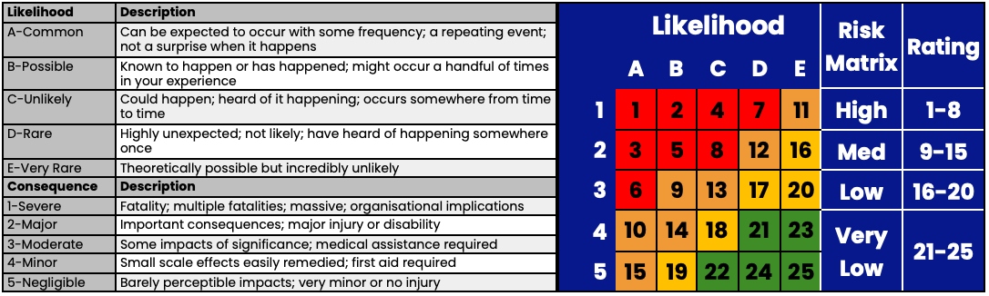

**SAMPLE**

|  |  |
| --- | --- |
| **SUNSW Risk Assessment Library (RAL) Site/Location Risks** | |
| **Site/Location** | **RAL Code**(s) |
| Campsite | LC001 |
| Common Risks | CR001 |
| Food Preparation | FC003 |
|  |  |

|  |  |  |  |  |
| --- | --- | --- | --- | --- |
| **Other Risks**  *Risks not in RAL or alterations to RAL Risk Assessment* | | | | |
| **Identified**  **Safety risk** | **Likelihood** | **Risk Level** | **Action plan**  *What we will do to reduce this risk to an acceptable level* | **Emergency Strategy**  *What we’ll do if this risk becomes reality* |
| **Consequence** |
| Falling Tree Branches | B-Possible | 9  Med | * Notify Caretakers of any fallen branches * Warn campers to look out for falling branches * Ask campers not to sit directly under Palm trees | * Follow Emergency Procedures * Apply First Aid * Track Patients recovery * Seek Emergency Medical Assistance if Necessary |
| 3-Moderate |
| Wildlife | Possible-B | 14  Med | * Don’t feed wildlife *(e.g. Ibis, Brush Turkey, Possum)* * Avoid wildlife *(don’t chase them)* * Keep all building doors closed * No food in cabins *(this can attract wildlife)* |
| Minor-4 |
| Trip Hazards  *(Uneven ground, tree roots, etc)* | Possible-B | 14  Med | * Warn campers of uneven ground/tree roots * Encourage campers & team to wear enclosed shoes except when going to the showers or the beach. * Mark particularly dangerous areas with witches hats. |
| Minor-4 |
| Sunburn  Heat Exhaustion  Heat Stroke | Possible-B | 14  Med | * Monitor and assess weather conditions regularly * Cancel, postpone, or stop the activity in the event of extreme weather conditions * Have adequate water available * Ensure that everyone is dressed appropriately for the weather conditions and length of activity * Sunscreen to be worn and available at all times * Take regular appropriate to weather conditions. |
| Minor-4 |

|  |  |  |  |  |  |
| --- | --- | --- | --- | --- | --- |
|  | | | | | |
| **MINISTRY** |  | **LOCATION** |  | **DATE** |  |

|  |  |
| --- | --- |
| * **Risk Management *IS* About** * Ensuring safety * Balancing benefits and risks with a focus on reducing real risks * Raising awareness of risks and managing them responsibly * Enabling individuals to understand that as well as the right to protection they also have to exercise responsibility | * **Risk Management *IS NOT* About** * Creating a totally risk free environment * Creating piles of paperwork * Stopping ministry or activities where the risks are managed |

|  |  |
| --- | --- |
| **In case of emergency call 000 and notify the Emergency Response Team**  **by text on 0483 900 140 or by phone on 02 9638 9099.** | |
| **Base location or site address:** | |
| **Best Contacts During Camp:** | |
| Contact 1: | Phone No: |
| Contact 2: | Phone No: |
| **Number of Toilets:** Male:                 Female:                 Unisex: | |
| **Number of Showers:** Male:                   Female:                 Unisex: | |
| **Sleeping Arrangements:** *e.g. cabins or tents, where are boys & girls, where are leaders* | |
| **Additional sites/locations:** *Please list venues, locations & purposes for which they will be used* | |
| **Please include a site map**  **and/or photos on next page** | Date of last leader’s  inspection of site(s): __/__/____ |

Insert site photos &/or map here



|  |  |
| --- | --- |
| **SUNSW Risk Assessment Library (RAL) Site/Location Risks** | |
| **Site/Location** | **RAL Code**(s) |
|  |  |
|  |  |
|  |  |
|  |  |

|  |  |  |  |  |
| --- | --- | --- | --- | --- |
| **Other Risks**  *Risks not in RAL or alterations to RAL Risk Assessment* | | | | |
| **Identified**  **Safety risk** | **Likelihood** | **Risk Level** | **Action plan**  *What we will do to reduce this risk to an acceptable level* | **Emergency Strategy**  *What we’ll do if this risk becomes reality* |
| **Consequence** |
|  |  |  |  |  |
|  |
|  |  |  |  |  |
|  |
|  |  |  |  |  |
|  |
|  |  |  |  |  |
|  |
|  |  |  |  |  |
|  |