|  |  |  |  |  |  |
| --- | --- | --- | --- | --- | --- |
|  | | **3. Budget** | | Ready,Set,Go | |
| **MINISTRY** | Camel Riding Camp | **LOCATION** | Oasis Beach Campsite | **DATE** | 29/9/23 - 2/10/23 |

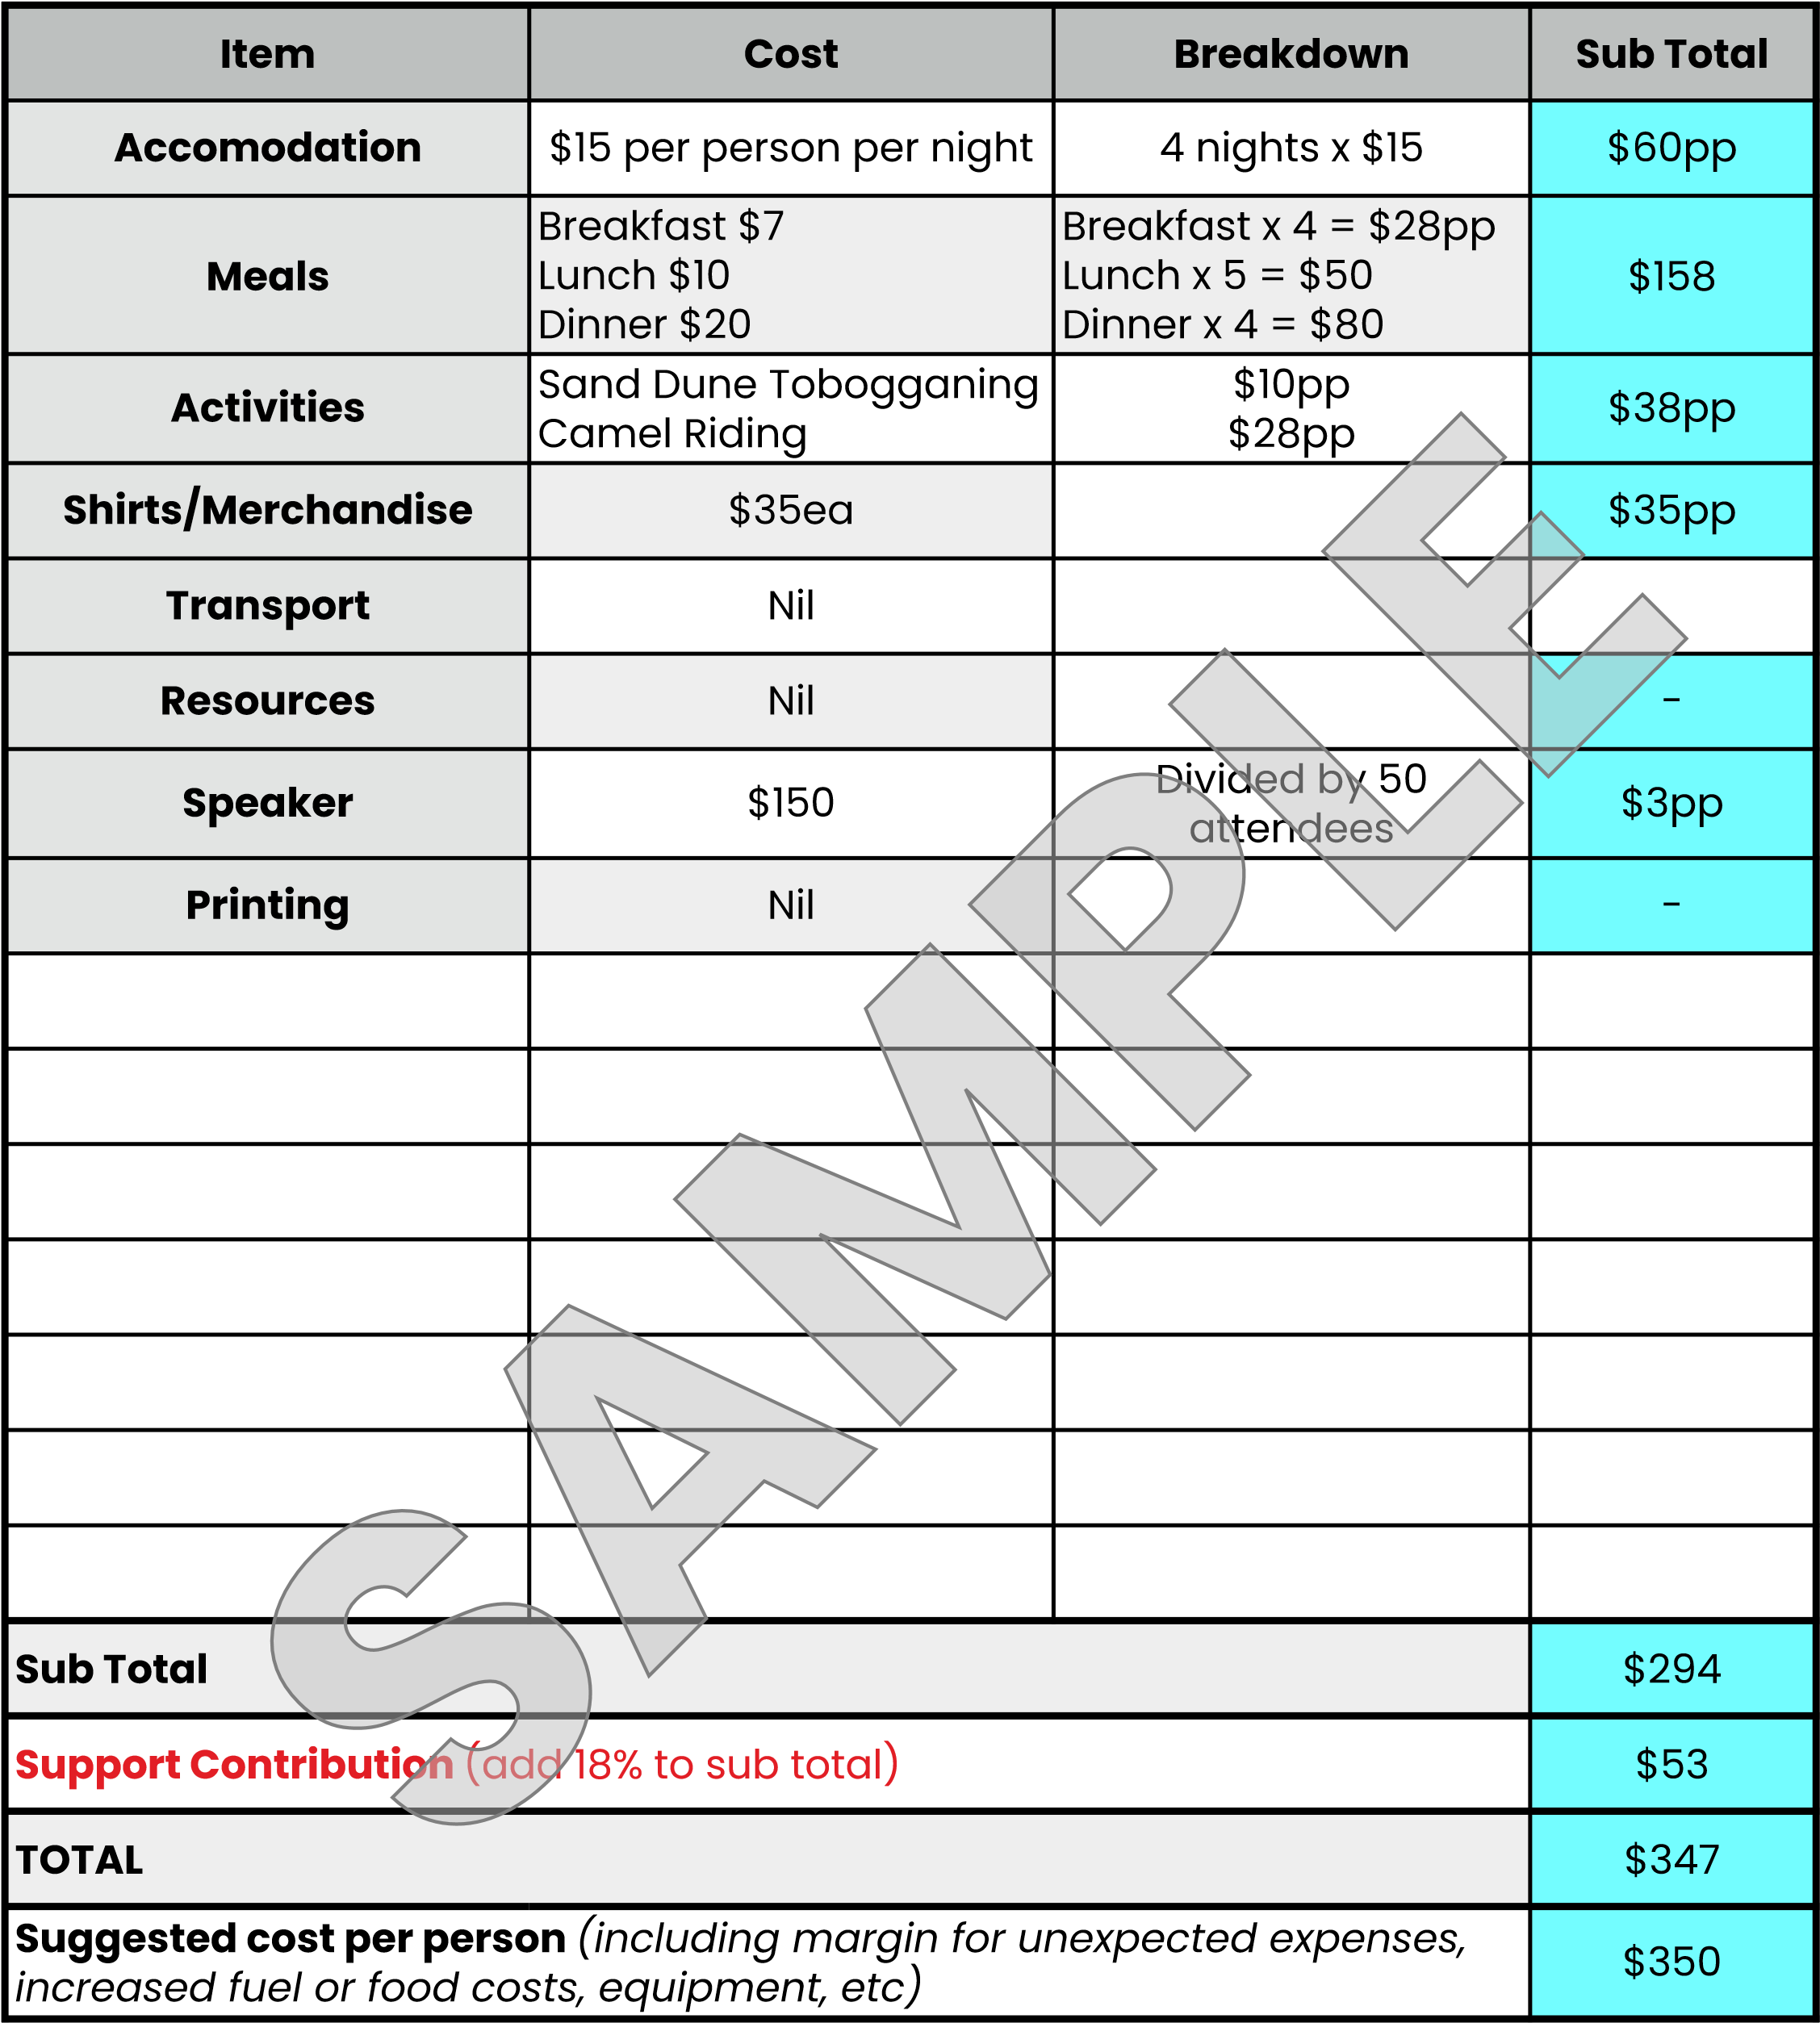

|  |  |  |  |  |  |
| --- | --- | --- | --- | --- | --- |
|  | **3. Budget** | | | Ready,Set,Go | |
| **MINISTRY** |  | **LOCATION** |  | **DATE** |  |

|  |  |  |  |
| --- | --- | --- | --- |
| Item | Cost | Breakdown | Sub Total |
| Accommodation |  |  |  |
| Meals |  |  |  |
| Activities |  |  |  |
| Shirts/ Merchandise |  |  |  |
| Transport |  |  |  |
| Resource |  |  |  |
| Speaker |  |  |  |
| Printing |  |  |  |
|  |  |  |  |
|  |  |  |  |
|  |  |  |  |

|  |  |
| --- | --- |
| **SUB TOTAL** |  |
| **SUPPORT CONTRIBUTION** (Add 18% to Sub Total) |  |
| **TOTAL** |  |
| **SUGGESTED COST PER CAMPER/TEAM MEMBER** (Including a margin for unexpected  expenses increased fuel or food costs, equipment etc) |  |