|  |  |  |  |  |  |
| --- | --- | --- | --- | --- | --- |
| **A picture containing text  Description automatically generated2. Activities Risk Assessments** | | | | | |
| **MINISTRY** | Camel Riding Camp | **LOCATION** | Oasis Beach Campsite | **DATE** | 29/9/23-2/10/23 |

|  |  |
| --- | --- |
| **Risk Management *IS* About**   * Ensuring safety * Balancing benefits and risks with a focus on reducing real risks. * Raising awareness of risks and managing them responsibly * Enabling individuals to understand that as well as the right to protection they also must exercise responsibility | **Risk Management *IS NOT* About**   * Creating a totally risk-free environment. * Creating piles of paperwork * Stopping ministry or activities where the risks are managed |

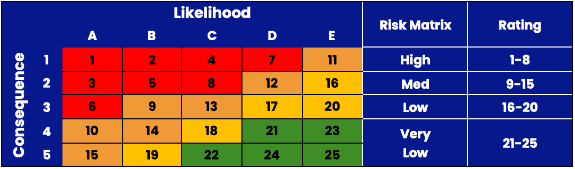

**SAMPLE**

|  |  |
| --- | --- |
| Likelihood | Description |
| A-Common | Can be expected to occur with some frequency; a repeating event; not a surprise when it happens |
| B-Possible | Known to happen or has happened; might occur a handful of times in your experience |
| C-Unlikely | Could happen; heard of it happening; occurs somewhere from time to time |
| D-Rare | Highly unexpected; not likely; have heard of happening somewhere once |
| E-Very Rare | Theoretically possible but incredibly unlikely |
| Consequence | Description |
| 1-Severe | Fatality; multiple fatalities; massive; organisational implications |
| 2-Major | Important consequences; major injury or disability |
| 3-Moderate | Some impacts of significance; medical assistance required |
| 4-Minor | Small scale effects easily remedied; first aid required |
| 5-Negligible | Barely perceptible impacts; very minor or no injury |

|  |  |
| --- | --- |
| **SUNSW Risk Assessment Library (RAL) Activities** | |
| **Activity** | **RAL Code**(s) |
| Indoor Games | GR003 |
| GTKY Games | GR010 |
| Scavenger Hunt | OT006 |
| Bonfire | EV007 |
| Bushwalking* | AD003 |
| Sand Dune Tobogganing | AD008 |
| Swimming | AQ007 |

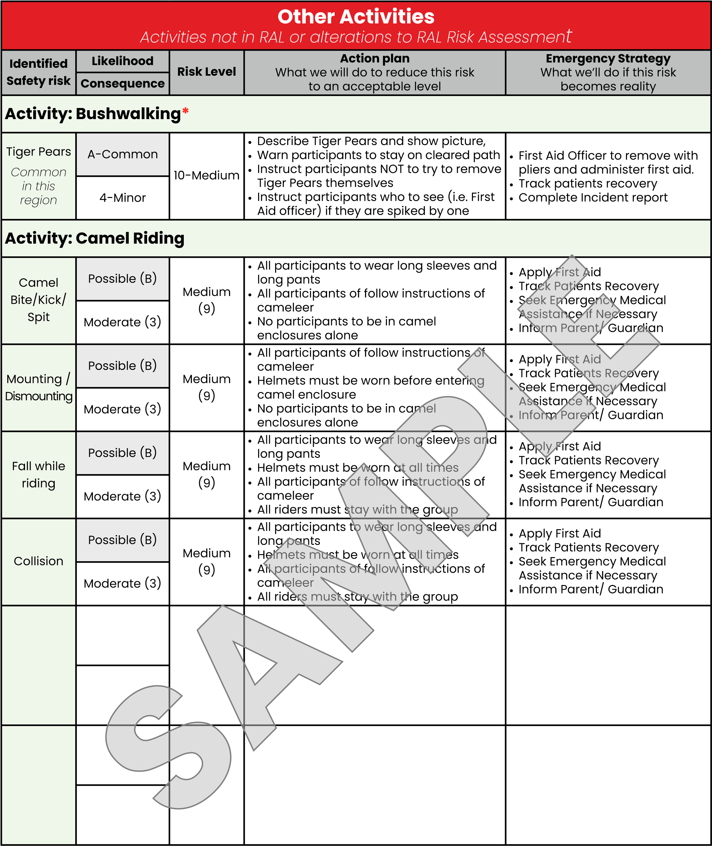

|  |  |  |  |  |  |
| --- | --- | --- | --- | --- | --- |
| **A picture containing text  Description automatically generated2. Activities Risk Assessments** | | | | | |
| **MINISTRY** |  | **LOCATION** |  | **DATE** |  |

|  |  |
| --- | --- |
| **Risk Management *IS* About**   * Ensuring safety * Balancing benefits and risks with a focus on reducing real risks. * Raising awareness of risks and managing them responsibly * Enabling individuals to understand that as well as the right to protection they also must exercise responsibility | **Risk Management *IS NOT* About**   * Creating a totally risk-free environment. * Creating piles of paperwork * Stopping ministry or activities where the risks are managed |



|  |  |
| --- | --- |
| Likelihood | Description |
| A-Common | Can be expected to occur with some frequency; a repeating event; not a surprise when it happens |
| B-Possible | Known to happen or has happened; might occur a handful of times in your experience |
| C-Unlikely | Could happen; heard of it happening; occurs somewhere from time to time |
| D-Rare | Highly unexpected; not likely; have heard of happening somewhere once |
| E-Very Rare | Theoretically possible but incredibly unlikely |
| Consequence | Description |
| 1-Severe | Fatality; multiple fatalities; massive; organisational implications |
| 2-Major | Important consequences; major injury or disability |
| 3-Moderate | Some impacts of significance; medical assistance required |
| 4-Minor | Small scale effects easily remedied; first aid required |
| 5-Negligible | Barely perceptible impacts; very minor or no injury |

|  |  |
| --- | --- |
| **SUNSW Risk Assessment Library (RAL) Activities** | |
| **Activity** | **RAL Code**(s) |
|  |  |
|  |  |
|  |  |
|  |  |
|  |  |
|  |  |
|  |  |
|  |  |
|  |  |
|  |  |
|  |  |
|  |  |

|  |  |  |  |  |
| --- | --- | --- | --- | --- |
| **Other Activities**  *Activities not in RAL or alterations to RAL Risk Assessment* | | | | |
| **Identified**  **Safety risk** | **Likelihood** | **Risk Level** | **Action plan**  What we will do to reduce this risk to an acceptable level | **Emergency Strategy**  What we’ll do if this risk becomes reality |
| **Consequence** |
| **Activity:** | | | | |
|  |  |  |  |  |
|  |
|  |  |  |  |  |
|  |
|  |  |  |  |  |
|  |
|  |  |  |  |  |
|  |
|  |  |  |  |  |
|  |

|  |  |  |  |  |
| --- | --- | --- | --- | --- |
| **Identified**  **Safety risk** | **Likelihood** | **Risk Level** | **Action plan**  What we will do to reduce this risk to an acceptable level | **Emergency Strategy**  What we’ll do if this risk becomes reality |
| **Consequence** |
| **Activity:** | | | | |
|  |  |  |  |  |
|  |
|  |  |  |  |  |
|  |
|  |  |  |  |  |
|  |
|  |  |  |  |  |
|  |
|  |  |  |  |  |
|  |

|  |  |  |  |  |
| --- | --- | --- | --- | --- |
| **Identified**  **Safety risk** | **Likelihood** | **Risk Level** | **Action plan**  What we will do to reduce this risk to an acceptable level | **Emergency Strategy**  What we’ll do if this risk becomes reality |
| **Consequence** |
| **Activity:** | | | | |
|  |  |  |  |  |
|  |
|  |  |  |  |  |
|  |
|  |  |  |  |  |
|  |
|  |  |  |  |  |
|  |
|  |  |  |  |  |
|  |

|  |  |  |  |  |
| --- | --- | --- | --- | --- |
| **Identified**  **Safety risk** | **Likelihood** | **Risk Level** | **Action plan**  What we will do to reduce this risk to an acceptable level | **Emergency Strategy**  What we’ll do if this risk becomes reality |
| **Consequence** |
| **Activity:** | | | | |
|  |  |  |  |  |
|  |
|  |  |  |  |  |
|  |
|  |  |  |  |  |
|  |
|  |  |  |  |  |
|  |
|  |  |  |  |  |
|  |